Colruyt Group fully committed to zero emission transport by 2035
Belgian retailer takes next ambitious step in reducing climate impact

Halle, 21 November 2022 - To further curb its climate impact, Colruyt Group intends to make all its goods transport zero emission by 2035. Both for its own transports to and from the stores and to the distribution centres via suppliers, the Belgian retailer intends to fully deploy zero emission vehicles. The company will achieve this by using complementary technologies: both battery-electric vehicles and hydrogen-electric vehicles will be needed to make this transition happen. Due to the in-house expertise of Virya Energy and DATS 24, as well as years of experience in transport, Colruyt Group is confident that this ambition will be accomplished. Moreover, the retail group actively discusses this in dialogue with the ecosystem of (transport) partners and suppliers that it works with closely.
A drastic reduction of climate impact
The ambition to go for zero emission transport by 2035 will have a significant impact on Colruyt Group's direct and indirect greenhouse gas emissions. The retail group currently emits 87,547 tonnes of CO₂ equivalent per year. In 2008, the group drew up a CO₂ balance for the first time, which resulted in a reduction plan focused on four hotspots: cooling, heating, energy and mobility. This reduction plan takes into account life-cycle analyses to reach the most eco-friendly solution for each specific application. Since then, emissions decreased both in absolute values and relative to sales for scope 1 and 2 (according to the Greenhouse Gas Protocol). Over the past five years (2017-2021), it even went down by more than 25% in absolute values. A trend the group is only too happy to continue.
By 2030, Colruyt Group wants to reduce its own emissions by another 42 per cent. "You cannot put the climate on hold, even though we have a lot of other things on our plate now as a big retailer. In October, it was still ten degrees too hot for the time of year and last summer was also clearly different. People continue to take to the streets for the climate and COP27 has just finished. We are convinced that, as a company, we must continue to invest in initiatives with a positive effect on the climate to create a better living environment, because time has now effectively run out,” Jef Colruyt, CEO of Colruyt Group, starts off by saying.
Just over a quarter of Colruyt Group's total emissions come from the fuel consumption of its own fleet, accounting for 23,797 tonnes of CO₂ equivalent (in scope 1 and 2 of the GHG Protocol). Another 60,000 tonnes of CO₂ equivalent come from freight transport by subcontractors driving on behalf of Colruyt Group. Finally, freight transport at the front of the value chain accounts for the very largest share of emissions, estimated at some 600,000 tonnes. By talking to suppliers and links all along the chain, Colruyt Group wants to actively tackle the latter parts, from scope 3, as well.

Caption: Comparison of categories within zero emission transport in tonnes CO₂-eq
Every day, customers walk out the Colruyt Group stores with an average of 640,000 shopping trolleys. Meeting this demand requires a lot of transport to be organised. Up to 700 drivers travel a total of 200,000 kilometres a day on average. Colruyt Group is already taking measures to keep the number of truck and van trips to a minimum. Trucks are also loaded for 94% before leaving. The first focus is indeed on avoiding unnecessary trips and optimally planning freight transport. Where possible, Colruyt Group also opts for alternative, more eco-friendly means of transport such as by rail and water. With what remains of trucks on the road, the aim is to go green.
Featured quote: "For our own freight vehicles, we expect to be zero emission by 2030. For our transport partners, suppliers and commercial vehicles, we count another five years on top of that."
Transport as an important factor in greening: hydrogen-electric as well as battery-electric
To realise its 2035 ambition, Colruyt Group will thoroughly scrutinise its current transport fleet. Both green hydrogen and battery-electric vehicles should become the norm in the near future. Colruyt Group believes that there is not just one way to more sustainable transport, but that a combination of different alternative fuels is essential. The complementarity in combining these alternatives ensures that the disadvantages of one technology are offset by the advantages of the other, such as charging time, deployability and infrastructure adaptations.
Jef Colruyt emphasises: "For us, this is really an and-and story. We always want to make the best techno-economic choices depending on the needs and logistical application. We are 100% committed to the transition towards zero emissions, making well-informed choices about the fuels used. We believe that electric driving can become the broad norm, it is becoming more and more established, also in a professional context. Hydrogen will also play an essential role in industry, in logistics processes and in transport activities. The most important thing for us is ultimately an evolution towards efficient and fluid transport with the smallest possible ecological footprint.”
In the field of technology and infrastructure, Colruyt Group takes a clear pioneering role. It has been doing so since 2005, when it first started research into electric trucks for silent delivery. The retail group was also the first to test heavy duty prototypes on hydrogen in Europe and it managed a silent delivery in an urban context with a 44-tonne electric truck. Solucious, Colruyt Group's online food wholesaler, also recently invested in Belgium's first five electric, refrigerated trucks. These trucks supply professional customers such as hospitals, catering businesses and companies in the inner city and outskirts of Brussels. They do so using 100% green energy, generated by Virya Energy's wind turbines.
Creating change along the chain: from supplier to customer
With Virya Energy, Colruyt Group can rely on extensive in-house expertise in the production of green hydrogen and electricity. In turn, DATS 24 is building the electric charging and hydrogen infrastructure in Belgium and Colruyt Group's innovative technical department also plays an important role. “We will proactively share our knowledge with all relevant partners in the chain. In the end, we want to create a broad buyer base and inspire the sector to make the transition to zero emission. That is why we have to make sure, together with our partners and the government, that there is enough long-term vision to realise our objective,” Jef Colruyt continued.
To have a real impact, all links in the chain must join the transition. Both the links that come before the store, as well as those that come after it. “It is very important for us to have impact across the chain. We do this not only by looking at ourselves, but also by actively engaging with our transport partners and suppliers. We actively want to commit to that. We do our bit and we want to inspire our customers to do the same. One of the initiatives is the recently launched sustainable savings programme for Eco-score A and B products, which allows customers to use points for local environmental projects. In this way, we contribute together to a better environment, step by step”, Jef Colruyt concludes.
A customer buying something at a Colruyt Group shop formula in 2035 can at least be sure that the product has been delivered to the shop by means of zero emission transport.
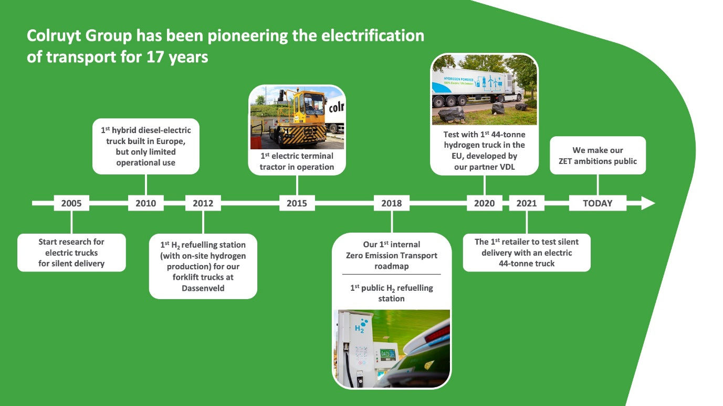
Caption: Timeline of zero emission transport (ZET) innovations at Colruyt Group since 2005

From the Colruyt Group annual report 2021, p. 192
This target is currently being formally validated by the Science-based Targets Initiative (SBTi) and will be finalised in 2023. Targets for scope 3 will also be announced next year.
For 94% to Colruyt shops in financial year '21.

